API Provider Migration

🌟 Definition
# Source: AI Source: Provided by: [Data Path: Persons Table -> ID Column: 1, Name_En Column: Motasem Essam] -> From: [ChatGPT] on [6/7/2026]
API Provider Migration is the process of switching from one API provider to another API provider while maintaining the same business functionality.
The application stops using the old provider's API and starts using a different provider's API.

🎯 Purpose
# Source: AI Source: Provided by: [Data Path: Persons Table -> ID Column: 1, Name_En Column: Motasem Essam] -> From: [ChatGPT] on [6/7/2026]
Organizations perform API provider migration to:
- Reduce costs
- Improve performance
- Access better features
- Improve reliability
- Enhance security
- Avoid vendor lock-in
- Meet business requirements

🧠 Simple Definition
# Source: AI Source: Provided by: [Data Path: Persons Table -> ID Column: 1, Name_En Column: Motasem Essam] -> From: [ChatGPT] on [6/7/2026]
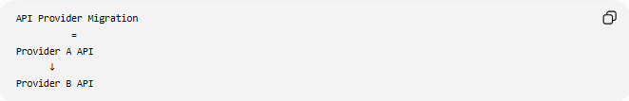
API Provider Migration
=
Provider A API
↓
Provider B API

📚 What is an API Provider?
# Source: AI Source: Provided by: [Data Path: Persons Table -> ID Column: 1, Name_En Column: Motasem Essam] -> From: [ChatGPT] on [6/7/2026]
An API provider is a company or service that offers APIs for developers to use.
Examples:
- Payment APIs
- Email APIs
- SMS APIs
- Maps APIs
- Authentication APIs
- Shipping APIs

🔍 Basic Example
# Source: AI Source: Provided by: [Data Path: Persons Table -> ID Column: 1, Name_En Column: Motasem Essam] -> From: [ChatGPT] on [6/7/2026]
Before
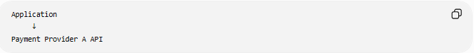
Application
↓
Payment Provider A API

After
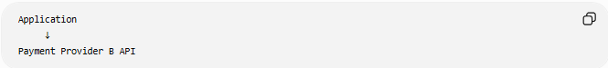
Application
↓
Payment Provider B API
The business process remains the same, but the API provider changes.

🏗️ Common API Provider Migration Scenarios

1️⃣ Payment API Migration
# Source: AI Source: Provided by: [Data Path: Persons Table -> ID Column: 1, Name_En Column: Motasem Essam] -> From: [ChatGPT] on [6/7/2026]
Before
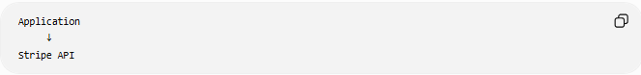
Application
↓
Stripe API

After
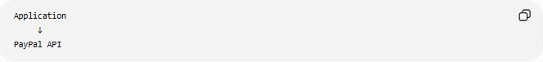
Application
↓
PayPal API
Purpose:
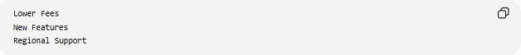
Lower Fees
New Features
Regional Support

2️⃣ Email API Migration
# Source: AI Source: Provided by: [Data Path: Persons Table -> ID Column: 1, Name_En Column: Motasem Essam] -> From: [ChatGPT] on [6/7/2026]
Before
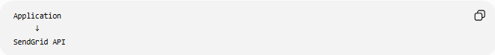
Application
↓
SendGrid API

After
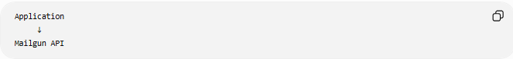
Application
↓
Mailgun API
Purpose:
Cost Optimization
Higher Delivery Rates

3️⃣ SMS API Migration
# Source: AI Source: Provided by: [Data Path: Persons Table -> ID Column: 1, Name_En Column: Motasem Essam] -> From: [ChatGPT] on [6/7/2026]
Before
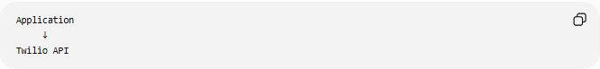
Application
↓
Twilio API

After
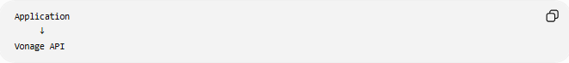
Application
↓
Vonage API
Purpose:
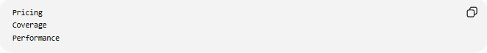
Pricing
Coverage
Performance

4️⃣ Maps API Migration
# Source: AI Source: Provided by: [Data Path: Persons Table -> ID Column: 1, Name_En Column: Motasem Essam] -> From: [ChatGPT] on [6/7/2026]
Before
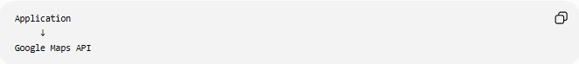
Application
↓
Google Maps API

After
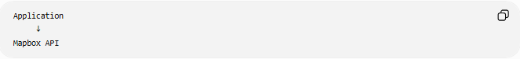
Application
↓
Mapbox API
Purpose:
Customization
Lower Cost

🛠️ Real-World Example
# Source: AI Source: Provided by: [Data Path: Persons Table -> ID Column: 1, Name_En Column: Motasem Essam] -> From: [ChatGPT] on [6/7/2026]
Before Migration
An application sends emails using:

POST /send-email
through Provider A.

Provider A Request
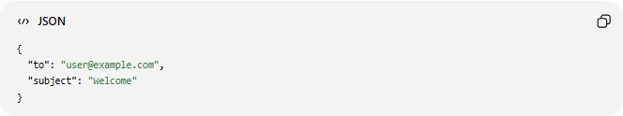
{
"to": "user@example.com",
"subject": "Welcome"
}

After Migration
The application uses Provider B.
Provider B Request
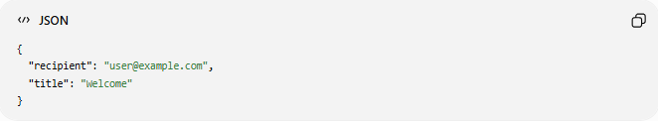
{
"recipient": "user@example.com",
"title": "Welcome"
}

The application code must be updated to match the new API.

🔄 API Provider Migration Lifecycle
# Source: AI Source: Provided by: [Data Path: Persons Table -> ID Column: 1, Name_En Column: Motasem Essam] -> From: [ChatGPT] on [6/7/2026]
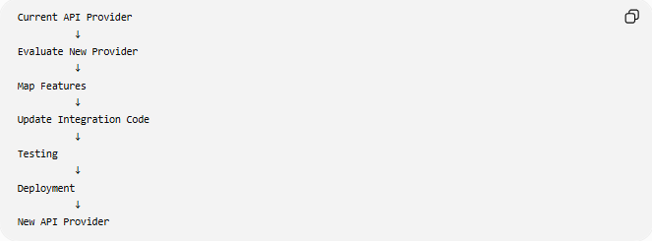
Current API Provider
↓
Evaluate New Provider
↓
Map Features
↓
Update Integration Code
↓
Testing
↓
Deployment
↓
New API Provider

📦 What Usually Changes?
# Source: AI Source: Provided by: [Data Path: Persons Table -> ID Column: 1, Name_En Column: Motasem Essam] -> From: [ChatGPT] on [6/7/2026]
API Endpoints
Before
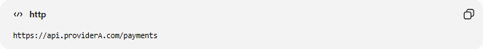
https://api.providerA.com/payments

After
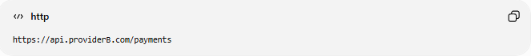
https://api.providerB.com/payments

Authentication
Before
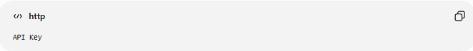
API Key

After
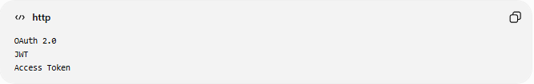
OAuth 2.0
JWT
Access Token

Request Format
Provider A
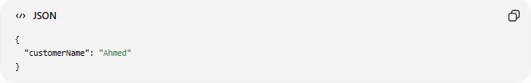
{
"customerName": "Ahmed"
}

Provider B
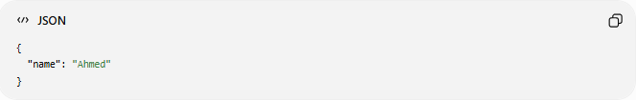
{
"name": "Ahmed"
}

Response Format
Provider A
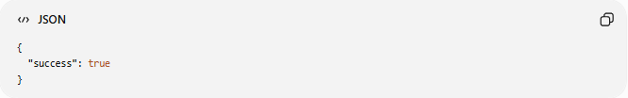
{
"success": true
}

Provider B
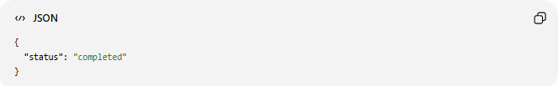
{
"status": "completed"
}

🌍 Example: SMS Provider Migration
# Source: AI Source: Provided by: [Data Path: Persons Table -> ID Column: 1, Name_En Column: Motasem Essam] -> From: [ChatGPT] on [6/7/2026]
Before
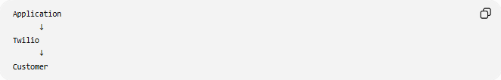
Application
↓
Twilio
↓
Customer

After
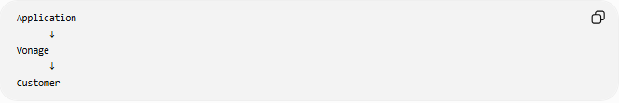
Application
↓
Vonage
↓
Customer
The customer still receives SMS messages, but a different provider delivers them.

⚠️ Common Challenges
# Source: AI Source: Provided by: [Data Path: Persons Table -> ID Column: 1, Name_En Column: Motasem Essam] -> From: [ChatGPT] on [6/7/2026]
Different API Designs
Providers may use completely different:
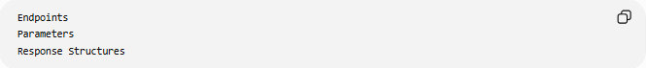
Endpoints
Parameters
Response Structures

Authentication Differences
The new provider may require:
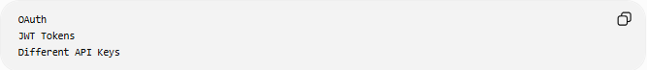
OAuth
JWT Tokens
Different API Keys

Feature Gaps
Some features available in the old provider may not exist in the new one.

Data Migration
Some providers store:
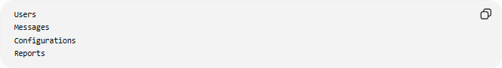
Users
Messages
Configurations
Reports
that may need migration.

Testing Effort
Every API workflow must be retested.

📊 Example Comparison
# Source: AI Source: Provided by: [Data Path: Persons Table -> ID Column: 1, Name_En Column: Motasem Essam] -> From: [ChatGPT] on [6/7/2026]
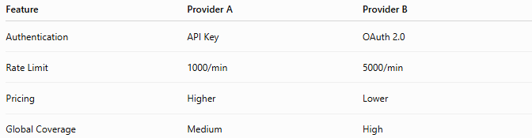
Feature | Provider A | Provider B
Authentication | API Key | OAuth 2.0
Rate Limit | 1000/min | 5000/min
Pricing | Higher | Lower
Global Coverage | Medium | High

✅ Benefits
# Source: AI Source: Provided by: [Data Path: Persons Table -> ID Column: 1, Name_En Column: Motasem Essam] -> From: [ChatGPT] on [6/7/2026]
Lower Costs
Reduced API Fees

Better Features
Advanced Functionality
More Services

Improved Reliability
Higher Availability
Better Support

Better Performance
Lower Latency
Faster Responses

Vendor Independence
Avoid Vendor Lock-In

📊 API Provider Migration vs API Version Migration
# Source: AI Source: Provided by: [Data Path: Persons Table -> ID Column: 1, Name_En Column: Motasem Essam] -> From: [ChatGPT] on [6/7/2026]
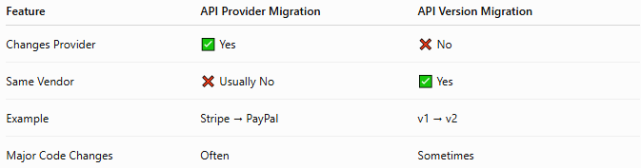
Feature | API Provider Migration | API Version Migration
Changes Provider | ✅ Yes | ❌ No
Same Vendor | ❌ Usually No | ✅ Yes
Example | Stripe → PayPal | v1 → v2
Major Code Changes | Often | Sometimes

API Provider Migration
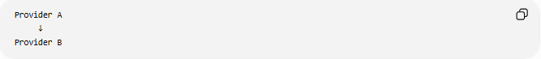
Provider A
↓
Provider B

API Version Migration
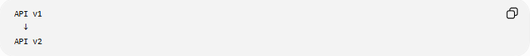
API v1
↓
API v2

🛠️ Common APIs Frequently Migrated
# Source: AI Source: Provided by: [Data Path: Persons Table -> ID Column: 1, Name_En Column: Motasem Essam] -> From: [ChatGPT] on [6/7/2026]
Payment APIs
- Stripe API
- PayPal API
Email APIs
- SendGrid API
- Mailgun API
SMS APIs
- Twilio API
- Vonage API
Maps APIs
- Google Maps Platform
- Mapbox

🧠 Simple Analogy
# Source: AI Source: Provided by: [Data Path: Persons Table -> ID Column: 1, Name_En Column: Motasem Essam] -> From: [ChatGPT] on [6/7/2026]
Imagine changing your internet service provider.
Before
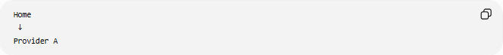
Home
↓
Provider A

After
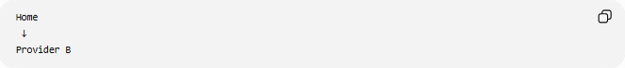
Home
↓
Provider B
You still use the internet, but the company providing the service changes.
API provider migration works the same way:
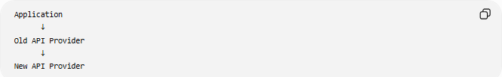
Application
↓
Old API Provider
↓
New API Provider
while preserving the business functionality.

🧭 Summary
# Source: AI Source: Provided by: [Data Path: Persons Table -> ID Column: 1, Name_En Column: Motasem Essam] -> From: [ChatGPT] on [6/7/2026]
API Provider Migration is a type of API migration where an application moves from one API provider to another, such as a payment API, email API, SMS API, or mapping API. The migration typically requires updating endpoints, authentication methods, request/response formats, and integration logic. The main goals are reducing costs, improving performance, accessing better features, increasing reliability, and avoiding vendor lock-in while maintaining the same business functionality.

